**Chapter 12: Magnetic Circuits**

Table of Contents

12.2 Magnetic Field 2

12.3 Reluctance 3

12.4 Ohm’s Law for Magnetic Circuits 4

12.5 Magnetizing Force 4

12.6 Hysteresis 5

How Magnets Work 6

12.9 Series Magnetic Circuits 7

The following chapter is the only one that is from Introductory Circuit Analysis (11th Edition) by Robert L. Boylestad. All other chapters are from Fundamentals of Electric Circuits (5th Edition) by Charles K. Alexander and Matthew N. O. Sadiku.

## 12.2 Magnetic Field

Flux Density ($B$) is the number of flux lines per unit area. It is measured in $Wb/m^{2}$ or $T$ (Tesla).

$$B=\frac{Φ}{A}$$

where $Φ$ is the flux in $Wb$ (webers) and $A$ is the cross-sectional area in $m^{2}$.

The pressure on the system to establish magnetic lines of forces is determined by the applied magnetomotive force ($Fe$), which is directly related to the number of turns and current in the magnetic coil. This is also known as the magnetic potential (as opposed to the electric potential). It is measured in ampere-turns ($At$).

$$Fe=NI$$

where $N$ is the number of turns in the coil and $I$ is the current in the coil in amperes.

Permeability ($μ$) is the ability of a material to support the formation of a magnetic field within itself. Thus, ferromagnets have a higher permeability, while wood and air have very low levels of permeability. The ratio of the permeability of a material to that of air is known as relative permeability ($μ_{r}$).

$$μ_{r}=\frac{μ}{μ_{0}}$$

where $μ=\frac{B}{H}$, the ratio of flux density in $Wb/m^{2}$ to magnetizing force in $At/m$ and $μ_{0}=4π×{10}^{-7}Wb/At⋅m$, the permeability of air.

## 12.3 Reluctance

Reluctance ($R$) is the resistance of a material to the setting up of magnetic flux. It is comparable to resistance in electrical circuits. It is measured in $rels$ or $At/Wb$.

$$R=\frac{l}{μA}$$

where $l$ is the length of the magnetic path in $m$, $μ$ is the permeability of the material in $Wb/At⋅m$ and $A$ is the cross-sectional area in $m^{2}$.

Reluctance is inversely proportional to permeability, as opposed to resistance which is directly proportional to resistivity.

## 12.4 Ohm’s Law for Magnetic Circuits

$Fe$ is the cause behind magnetic flux, and $R$ opposes it. Thus, magnetic flux can be expressed as

$$Φ=\frac{Fe}{R}$$

This is similar to $I=\frac{V}{R}$ is electrical circuits. However, flux is not a flow of anything, like current is a flow of charge. Magnetic flux is rather established through an alteration of the atomic structure of the core due to external pressure.

## 12.5 Magnetizing Force

The magnetomotive force per unit length is called the magnetizing force ($H$). It is measured in $At/m$.

$$H=\frac{Fe}{l}=\frac{NI}{l}$$

For example, if $NI=40 At$ and $l=0.2 m$, then $H=200 At/m$. This means that there is $200 At$ of ‘pressure’ per meter to establish flux in the core. Interestingly, the magnetizing force does not depend on the type of material used to make the core.

## 12.6 Hysteresis

A curve of the flux density $B$ against the magnetizing force $H$ for a particular material is known as its $B-H$ curve.



When $I$ is initially increased from $0$, the curve follows the path from $o$ to $a$ and onwards. If current is increased to the point of saturation at $b$, $H$ will continue to increase, but $B$ will increase in insignificantly small amounts. $B$ has essentially reached its maximum value.

If $I$ is now decreased to $0$, $H$ will drop to $0$ as well, but $B$ will not. It follows the path from $b$ to $c$. The flux density $B_{R}$, which remains when $H=0$, is called the residual flux density. This residual is what allows the creation of permanent magnets. If the coil is now removed from the core, the core will retain its magnetic properties.

If the direction of $I$ is now reversed, $B$ will begin to decrease, while $H$ attains negative values. The curve follows the path from $c$ to $d$. Eventually, $B=0$ at $-H_{d}$. $-H_{d}$ is the magnetizing force needed to ‘coerce’ (persuade forcefully) the flux density to reduce to $0$ and is called the coercive force, which is a measure of the coercivity of the magnetic sample.

If current continues to increase, the curve goes from $d$ to $e$, reaching the negative saturation point. If current is then reversed again, the curve will go from $e$ to $f$ and back to $b$. This entire curve is called a hysteresis curve (from the Greek hysterein, meaning ‘to lag behind’, since $B$ lags behind $H$ the entire way).

The curve obtained for a particular core depends on the maximum value of $H$ applied. Larger values will increase the saturation points.

The area inside the curve represents the energy lost in magnetizing and demagnetizing the substance.

### How Magnets Work

For every atom, the electrons revolving around the nucleus are also spinning, thus causing a magnetic field to arise since a moving charge will cause a magnetic field. In non-magnetic materials, the overall magnetic field is essentially $0$. However, for magnetic materials, the magnetic fields of large numbers of atoms effectively create small magnets inside the material, each of which is called a domain. For an unmagnetized magnetic material, the domains will cancel out so that the magnetic field in any direction appears to be $0$. However, when placed under the influence of strong external magnetic force, the domains that even partially align with the force begin to attain its orientation. As the strength of the force is increase, eventually, all the domains have the same orientation, a point called saturation, and any further increase in strength does not increase the magnetic flux. When the force is removed, some of the misaligned domains reappear, decreasing the flux density to $B_{R}$. A number of the domains retain their alignment however, thus forming a permanent magnet.

## 12.9 Series Magnetic Circuits

Magnetic circuits can be thought to work similarly to how electric circuits work. Thus, they can be solved in exactly the same manner.



Example 12.1



The given $B-H$ curve will be required.

For $Φ=4×{10}^{-4} Wb$, $B=\frac{Φ}{A}=\frac{4×{10}^{-4}}{2×{10}^{-3}}=0.2 T$. From the $B-H$ curve, $H=170 At/m$ for cast steel.

$$Fe=ΦR$$

$$NI=Φ×\frac{l}{μA}$$

$$I=\frac{Φ}{N}×\frac{l}{\frac{B}{H}×A}=\frac{4×{10}^{-4}}{400}×\frac{0.16}{\frac{0.2}{170}×2×{10}^{-3}}=0.068 A$$

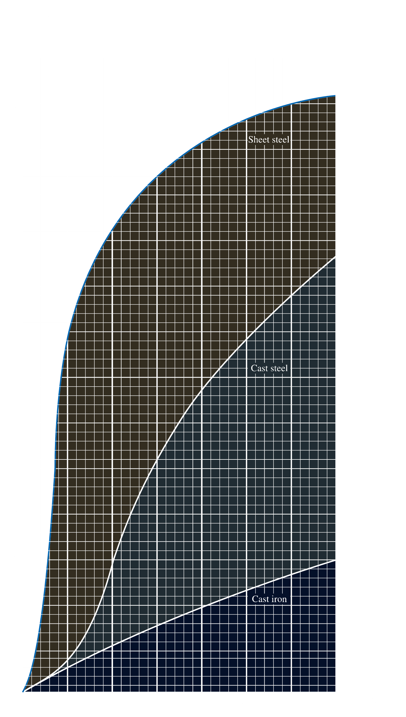

Relationship Between Electric and Magnetic Circuits

$V=IR$ $Fe=ΦR$

In a closed loop, $∑V=0$. In a closed loop, $∑Fe=0$.

At a node, $I_{in}=I_{out}$. At a node, $Φ_{in}=Φ_{out}$.